Страница конкретного художника. Общее описание.

6 кнопок всего

**Overview Works Exhibitions**

**Download Artist CV Press-Hooks Channel**

Сразу открывается одна картинка и подпись под ней

И одна из важных цитат про художника под этой картинкой. Пример: https://www.victoria-miro.com/artists/19-chantal-joffe/

***

текст Overview виден сразу

**Ниже картинки работ художника вряд – они же при нажатии на Works.**

**При нажатии на каждую картинку она открывается отдельно:**

**Слева все данные и кнопки**

**Например:**

**Katia Kesic**

*You Are Beautiful, 2019*

Underglaze on stoneware clay, ribbon roses, crystals

44 x 40 x 40 cm

GBR 3,500

Excludes taxes and additional fees

**Sales Inquiry - кнопка**

Значок «**поделиться**» и **View on the Wall**

Здесь же другие виды этой работы, маленькие квадратики вряд.

_________________

Description

___________________

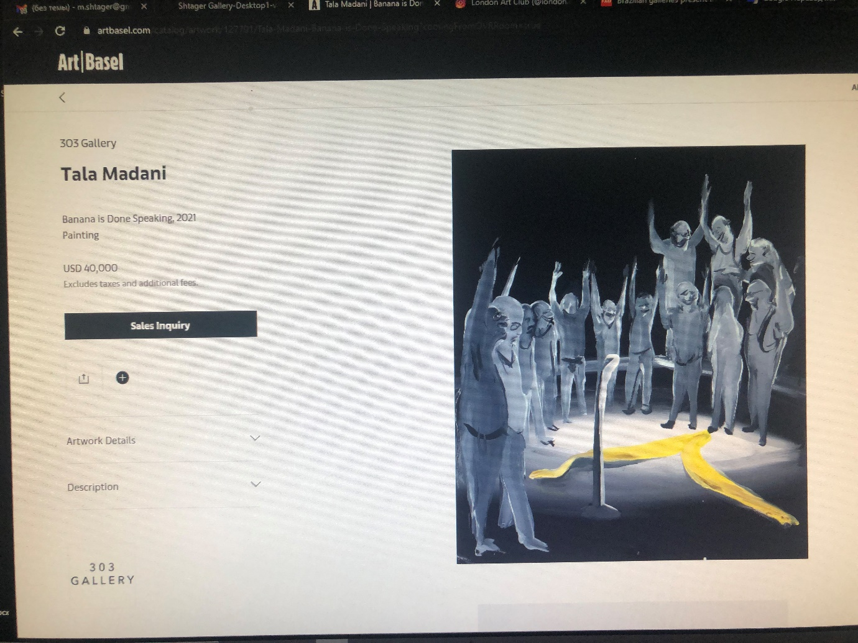

(На фото выше хорошо сделана кнопка Description - при нажатии на нее открывается описание /история картирны (будет не у всех картин/скульптур)

Но слово Description не надо – оно уже будет дано. Плюсик не надо, а вот **Share** нужно сделать.

**Несколько видов одной работы хорошт сделано тут: https://thesundaypainter.co.uk/artists/44-emma-hart/works/2070-emma-hart-bat-blue-red-2020/**

**View on the Wall - при нажатии открывается вид на стене, либо на пьедестале у стены, если это скульптура.**

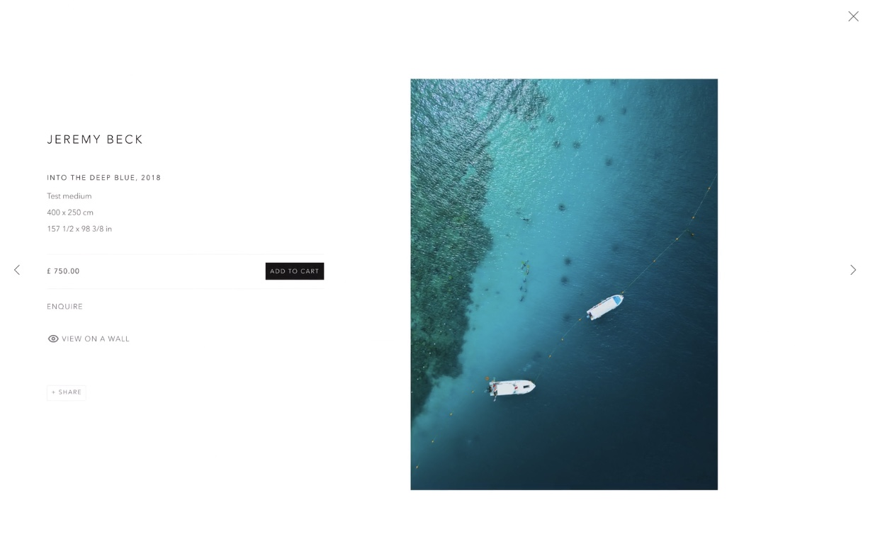

На фото выше хорошо сделана кнопка **View on the Wall**

**При нажатии она открывается на стене:**

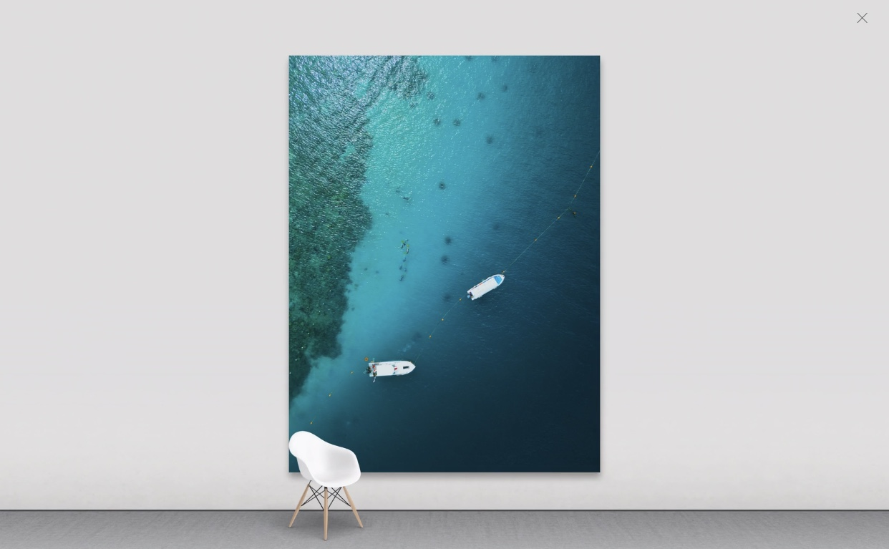

Страница **Katia Kesic**

**Overview Works Exhibitions**

**Download Artist CV Press-Hooks Channel**

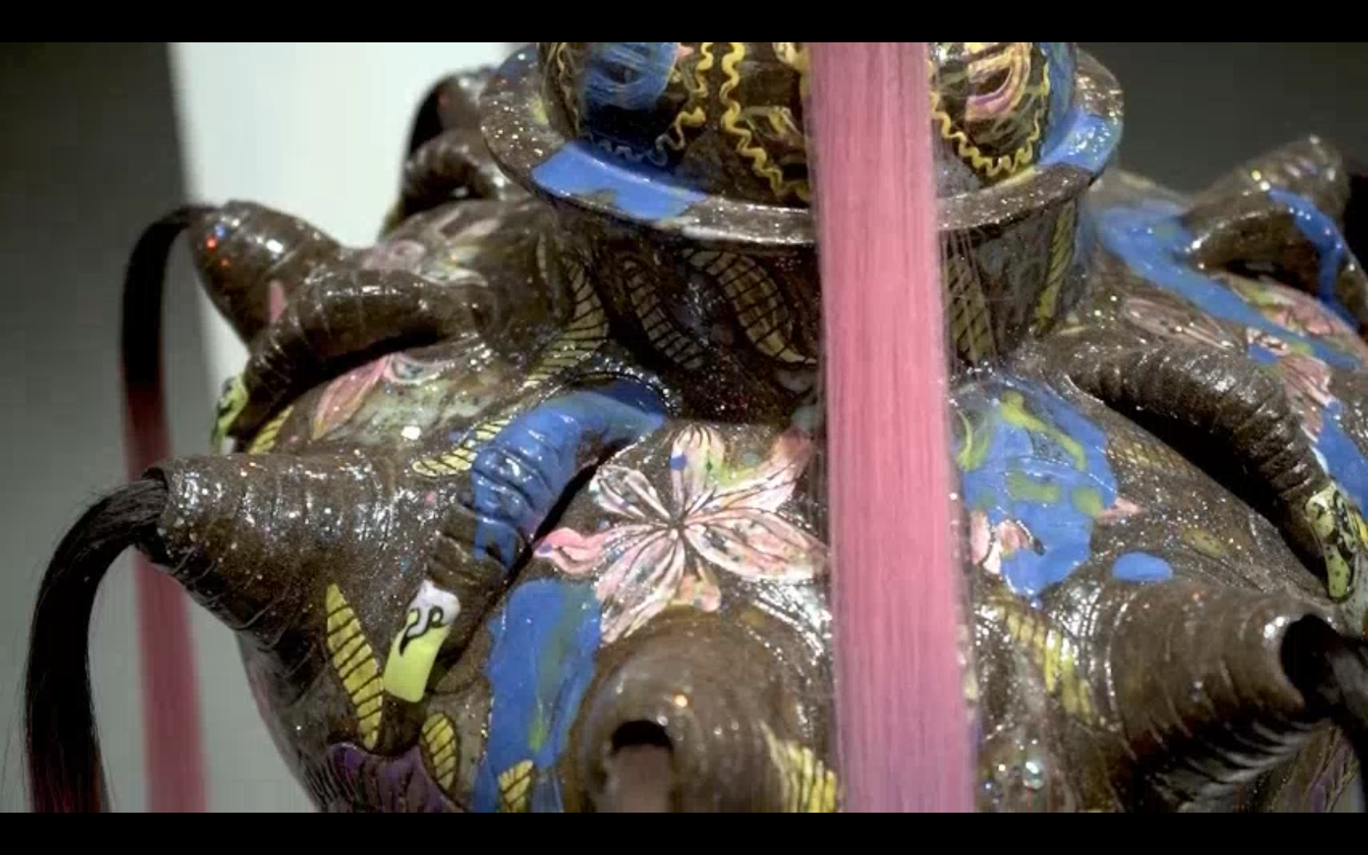

**(Именно Кесич тут можно начать с окна видео, которое называется Only Vases – посылаю We Transfer) и выбрать этот кадр для заставки, если возможно) тут же нужно указать автора видео. Video by Rocio Chacon**

*My memory vessels series are based on the subjective process and documentation of exploring my identity. Each vase has its own unique narrative, echoing fragments of my reality at certain points of my life after moving to the UK. These elements consist of my associations, imagination, patterns, cosmic and esoteric symbols, people and conversations I overheard, and dreams, unfolding as their own visual language and mythology. I’m drawn to ceramics both as a medium and a craft that is traditionally associated with functionality and labour, rather than Fine Art. Vessels are also associated with an act of conjuring, thus bearing a connection to rituality. My vases allow me to merge various narratives together non-hierarchically into speculative assemblages of different worlds, while their three-dimensionality adds a textural and visceral dimension that I feel grounds my process, experience and work firmly in the present.*

*(если текст длинный, более 5 строчек, то делать линию и слова + view more) пример: https://www.victoria-miro.com/artists/19-chantal-joffe/*

About the Artist

Katia Kesic was born in Moscow, in 1986 and moved to London in 2012.

Katia explores the human body as a memory vessel which collects traces of one’s reality/inner subjectivity and the imagination. The African fabric patterns of Brixton, memorised view from Moscow flat, cosmic and esoteric symbols of media/fashion trends & their aesthetics - she is using all this information stream as a source for her works. By converting these influences into an independent elements, she is creating one’s own mythology. Katia distancing herself from the layers of memory and associations in order to get to their essence, whilst speculating on how much our personal identity is influenced by the inner or the outer world; be it immigration, sexuality, connection to the environment etc. Hands-on experience /process is equally important as an idea. Katia graduated Moscow State Academic Art college in memory of 1905, Stroganov Moscow State Academy of applied arts, Chelsea College of Arts and London Metropolitan University. Since 2015 she has been taking part in shows in Russia and the UK.

## Selected Works

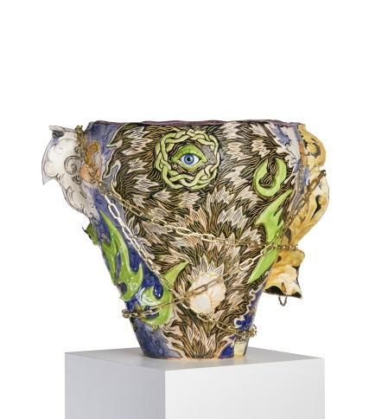 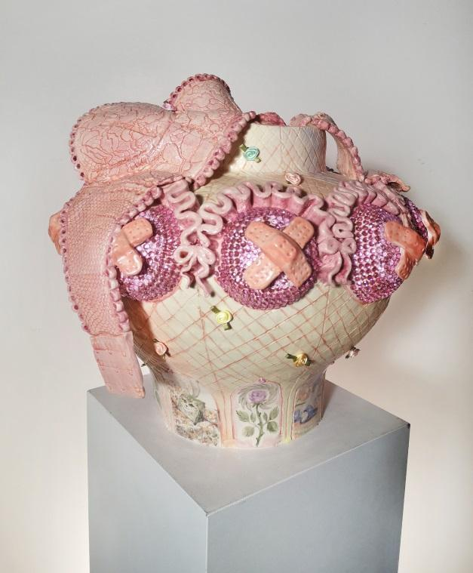

Let me tell you what happens next, 2019 You Are Beautiful, 2019

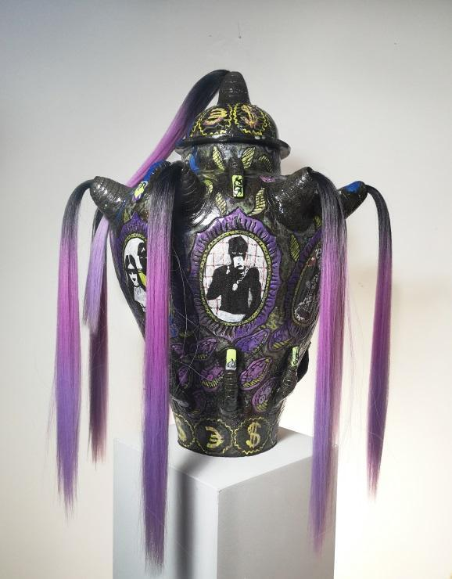 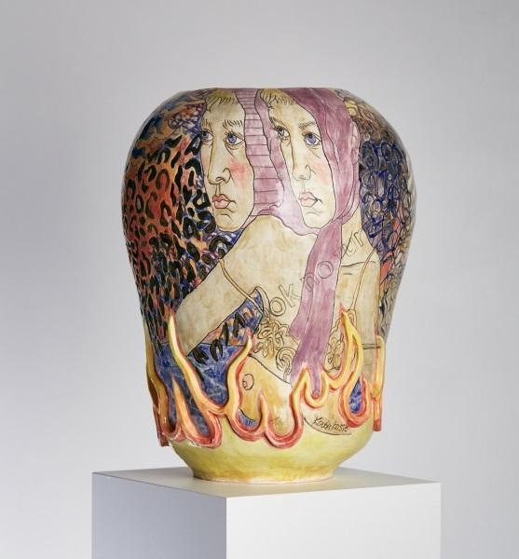

Black Magic, 2019 Look No Further, 2019 Look No Further, (2019)

Послыю все фото we transfer – выбрать эти виды но на белом фоне поиграть с ними чтобы хорошо смотрлись вместе в ряд или в два ряда.

****

Теперь информация к каждой из ваз, когда нажимаешь на них.

**Katia Kesic**

**Let me tell you what happens next, 2019**

Underglaze on stoneware clay, chain, glass eye

34 x 33 x 33 cm

GBR 3,500

Excludes taxes and additional fees Тут видео вращающейся вазы

**Sales Inquiry - кнопка**

Значок «**поделиться**» и **View on the Wall**

Здесь же другие виды этой работы, маленькие квадратики вряд.

 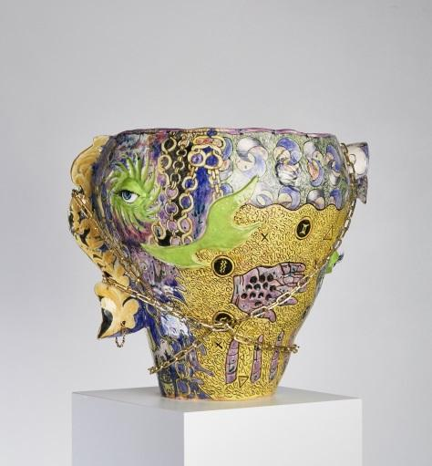 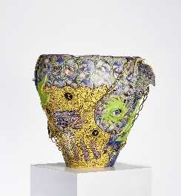

При нажатии открываются большими

_________________

Description

___________________

*‘’Let me tell you what happens next’’,* 2019 was influenced by my interest in spirituality, magic and astrology, featuring various symbols and motifs from tarot cards. Two completely different worlds collapse into one another in this vase: Russian folkloric motifs such as monograms and traditional ornate patterns that are integrated with imagery from my local South London neighbourhood. Both are infused with different kinds of visceral nostalgia and symbolic significance. The “third eye” or mind’s eye on this work speculates the possibilities within the realm of dreams, the subconscious and alternative, mediumistic predictions of the future.

**Katia Kesic**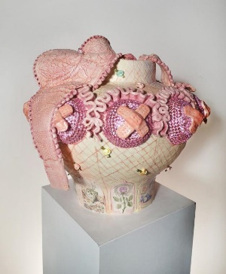

**You Are Beautiful, 2019**

Underglaze on stoneware clay, ribbon roses, crystals

44 x 40 x 40 cm

GBR 3,500

Excludes taxes and additional fees Тут видео вращающейся вазы

**Sales Inquiry - кнопка**

Значок «**поделиться**» и **View on the Wall**

Здесь же другие виды этой работы, маленькие квадратики вряд.

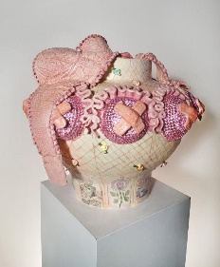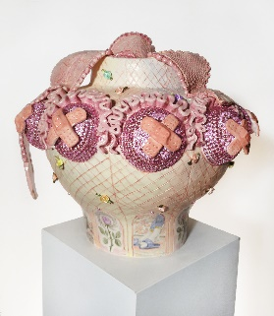 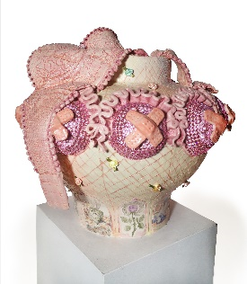

При нажатии открываются большими

_________________

Description

___________________

1. *‘’You are beautiful’’,* 2019 speculates on how much our personal identity, sexuality and consciousness is shaped by both external and internal forces. It’s a meditation on vulnerability and how fragile and exposed we can feel under someone else’s judgments and the expectations of social norms. This sense of vulnerability and self-protection is symbolised through the covered nipples of the breast-shaped detailing around the vase, while the rose ribbons are made from lingerie, alluding to a space of intimacy and care shared both with oneself and with another person. The images at the bottom of the vase tell the story of a gentle Chelsea FC fan in his pink bathroom with a yellow rubber duck and cushions with kittens as a playful subversion of macho masculinity, gender roles and societal expectations.

**Katia Kesic**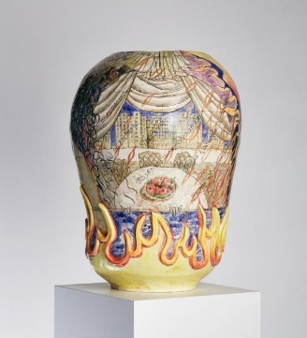

**Look No Further, (2019)**

Underglaze on stoneware clay, ribbon roses, crystals

34 x 33 x 33 cm

GBR 3,500

Excludes taxes and additional fees Тут видео вращающейся вазы

**Sales Inquiry - кнопка**

Значок «**поделиться**» и **View on the Wall**

Здесь же другие виды этой работы, маленькие квадратики вряд.

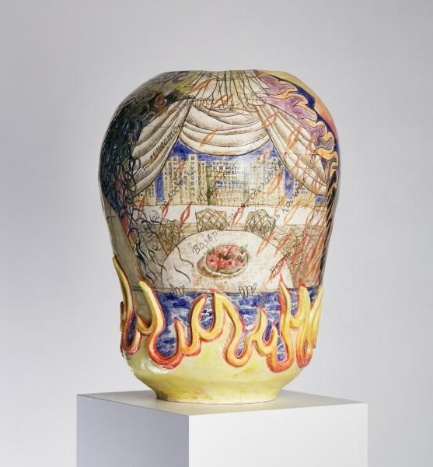 

При нажатии открываются большими

_________________

Description

___________________

*‘’Look no further’’,* 2019 is a work that appeared at the crossroads of my life. The dramatic imagery captures the intensity of the sense of double consciousness I experienced living physically and mentally in two countries. The scene on this vase overlays the view from my Moscow flat and a dual portrait of mine, engulfed by flames. It is a testament to my homesick reflections, confusion and awareness of a new environment’s influence on my identity and practice. I was also influenced by a famous rhyme from one Russian fairy tale about magic flower which makes the ones wishes came true:‘’ Fly the petal of, East or west you go, Touch the ground to, Make my wish come true’’. This rhyme is included in the imagery on the vessel in Cyrillic letters.

**Katia Kesic**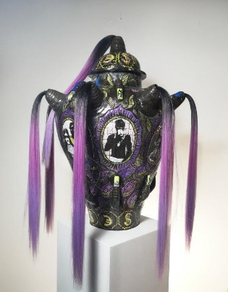

*Black Magic, 2019*

Underglaze on stoneware clay, artificial hair, nails, nail polish

65 x 45 x 45 cm

GBR 3,500

Excludes taxes and additional fees Тут видео вращающейся вазы

**Sales Inquiry - кнопка**

Значок «**поделиться**» и **View on the Wall**

 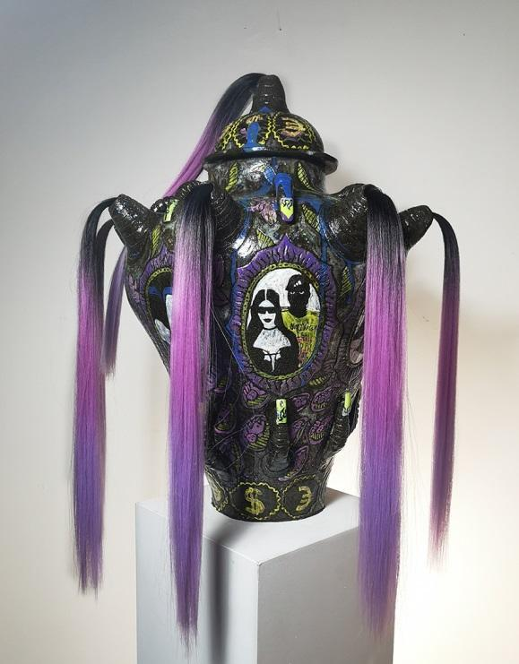

_________________

Description

___________________

*‘’The Black Magic‘’,* 2019vase was born while I was living in Brixton, fascinated with the very strong identity, community and spirituality around me that was alien to me. It’s my tribute to the Afro-Caribbean culture I was witnessing as a kind of magic. For the vessel’s form itself, I referenced traditional African vases pots by The Igbo people of Nigeria in ceremonial and everyday contexts. I was also inspired by the skin scarification tradition, which can identify social, marriage status, tribal and religious affiliation etc. hence using grooves and carving techniques on clay. I depicted people and patterns I saw in Brixton market, my neighbours and teenagers’ media culture icons like Kim Kardashian and Kanye West. For my materials, I used black body clay, purple and hair extensions and acrylic nails from Brixton village. The colour purple is of symbolic significance in Black culture and icons such as Prince. In traditional African Art and folk Art in particular, purple is a regal colour associated with royalty, luxury, wisdom and passion. Purple textiles are often worn by women, and so it also has a connection to femininity. The iconography and visual language merges motifs from popular culture with elements of ritual, spirituality and voodoo.

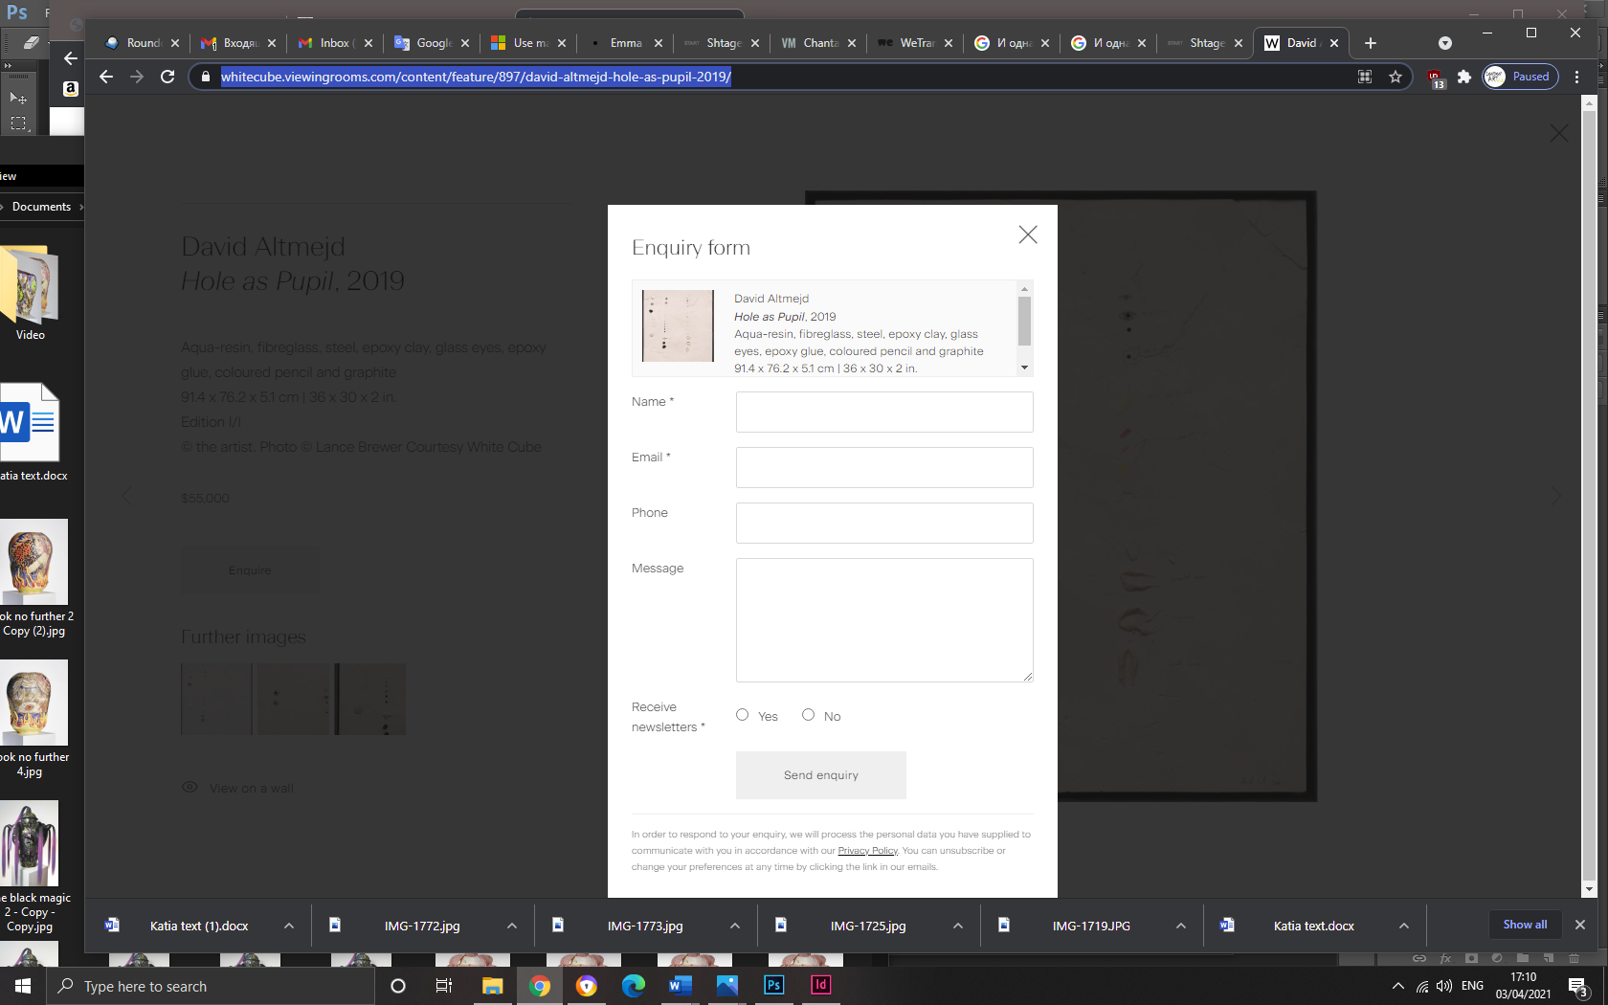Enquiry Form

Вверху формы повторяется фото работы и ее атрибцуия, внизу Policy:

In order to respond to your enquiry, we will process the personal data you have supplied in accordance with our privacy policy (available on request). You can unsubscribe or change your preferences at any time by clicking the link in our emails.

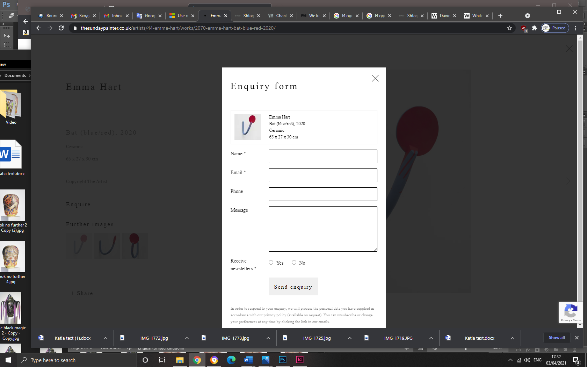

Пример:

https://thesundaypainter.co.uk/artists/44-emma-hart/works/2070-emma-hart-bat-blue-red-2020/

<https://whitecube.viewingrooms.com/content/feature/897/david-altmejd-hole-as-pupil-2019/>

**Katia Kesic**

Press-hocks

При нажатии на картинку открывается пдф файл – посылаю we transfer

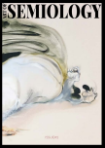

ART OF SEMIOLOGY MAGAZINE. Issue#2. Katia Kesic ceramics. Pages 55-66

semiology-mag.com

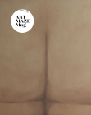

ARTMAZE MAGAZINE. Edition 21. 2021: curated selection. Katia Kesic. Page 97

artmazemag.com

# Катя Кесич

# ArtAndYou КАТЯ МАЦИЕВСКАЯ-КЕСИЧ: "В керамике мне намного свободнее". March 2021

https://artandyou.ru/interview/artists/katya-maczievskaya-kesich/

Artandyou.ru